ACCESS MANAGEMENT
With continuation of previous post (snowflake_47),
Let’s also give grants to QA role & reader role as well
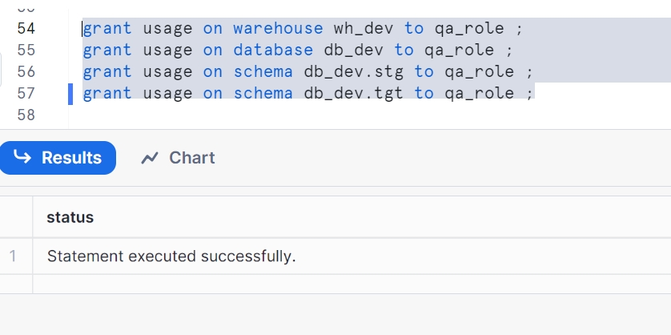
No insert and delete on stg to QA, No insert in tgt this implies no access to insert and delete in stg schema to qa_role, no access to insert in tgt schema to qa_role
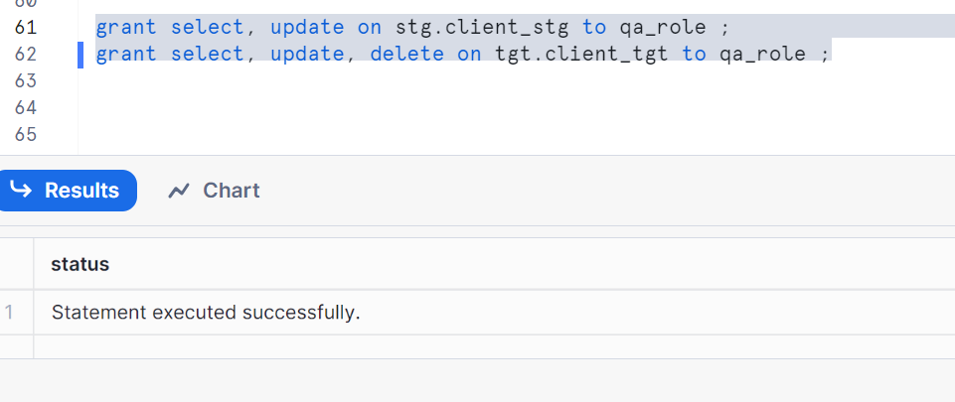

Giving grants to qa_role on procedure and view as well
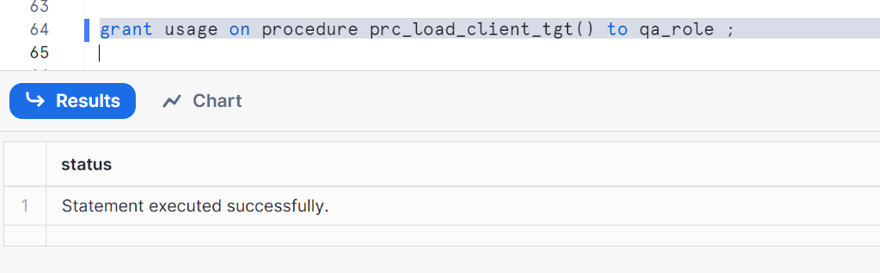
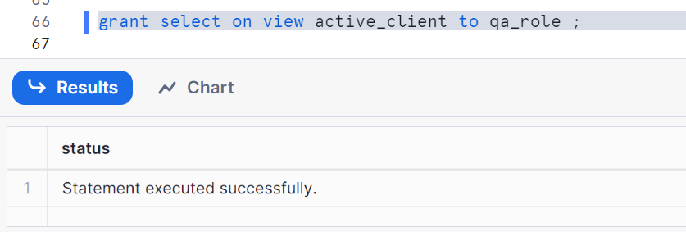

Now, let’s give access to read_role ---- just select access, no procedure execution
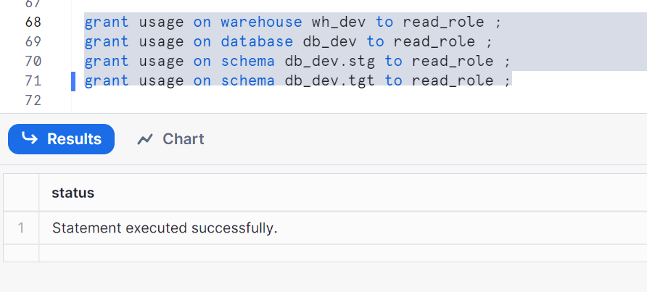

Only select on table, no other grants in read_role except select
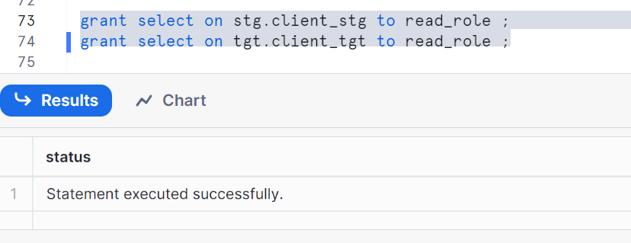
Grant on view
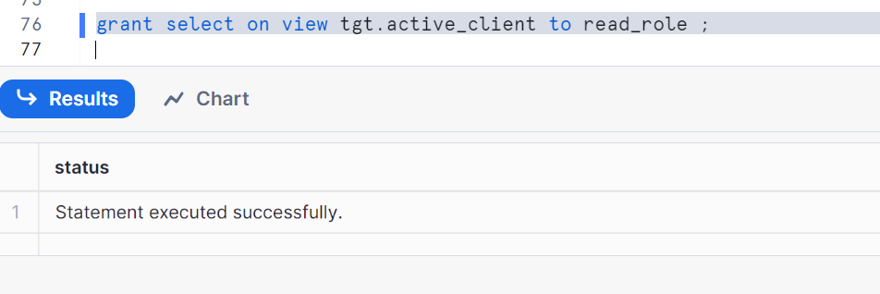

Now, let’s assume a new developer is joining your team
Just give that developer role to that user. You can create a user and give a developer_role to that user.
Assume developer_1 & developer_2 are two such persons.

Now logout from current sysadmin and login to developer1
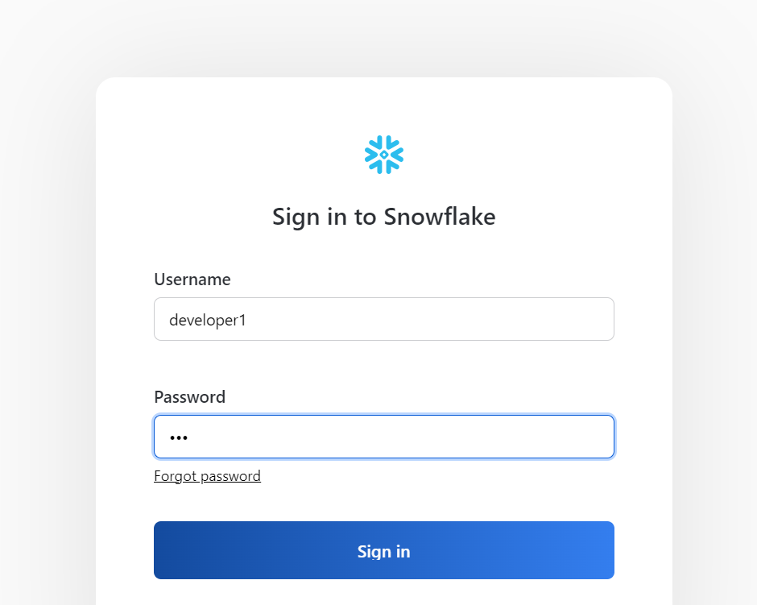
Here is the access that we got to different databases, schemas & warehouses as shown below
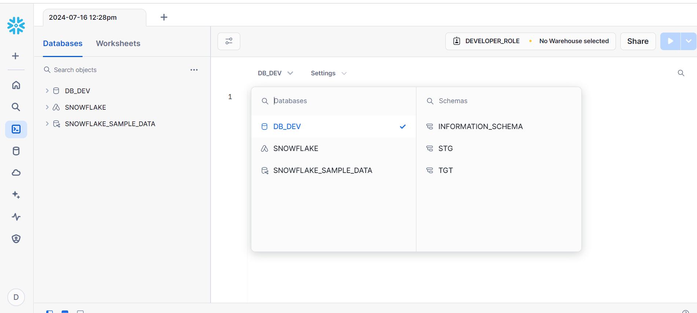
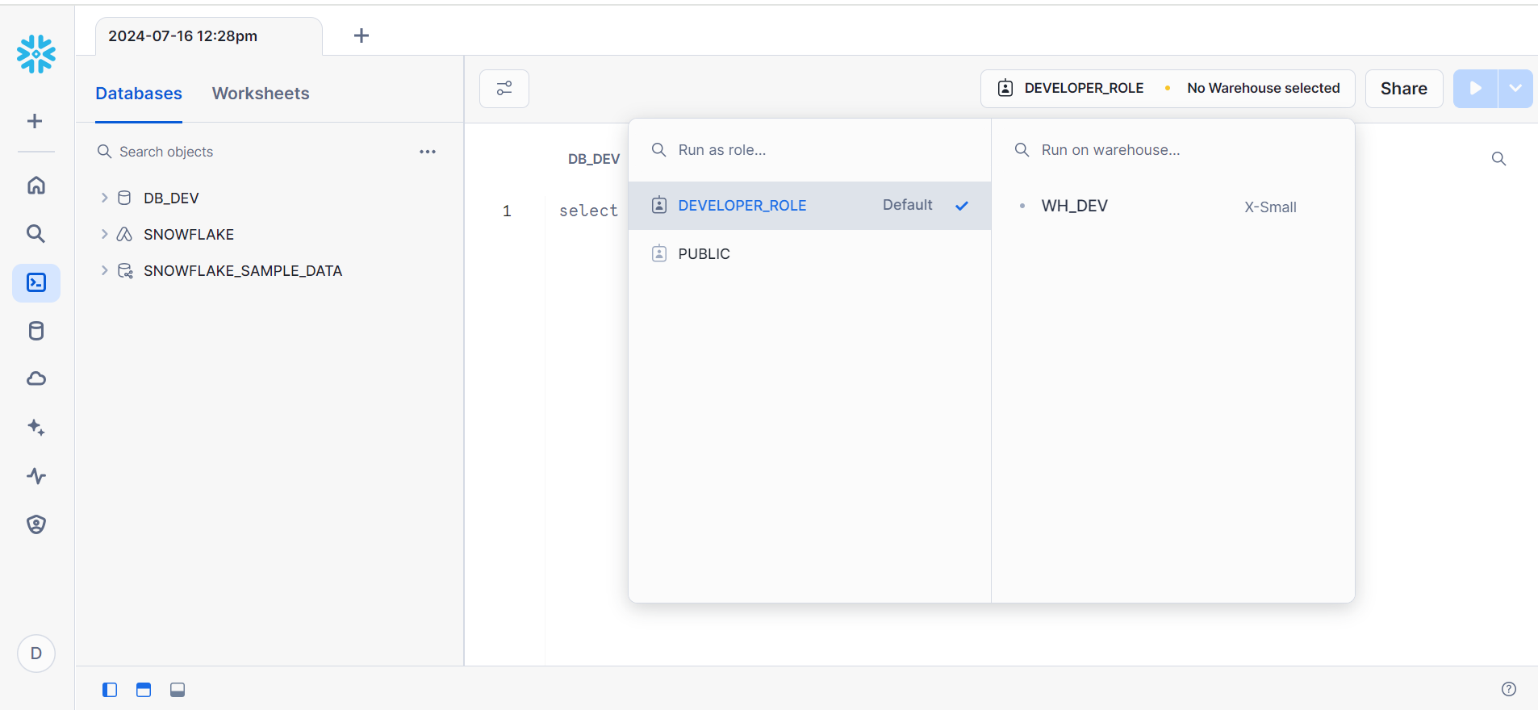
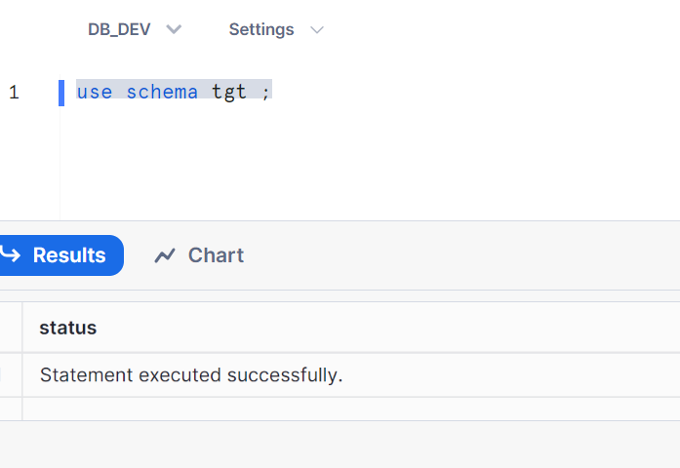

Let’s check, are we able to create a table in the present user developer1
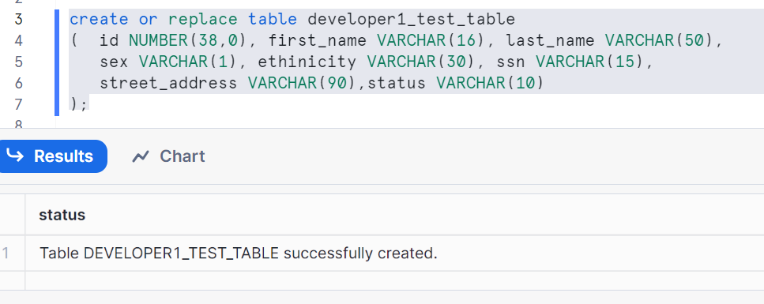
Check with insert
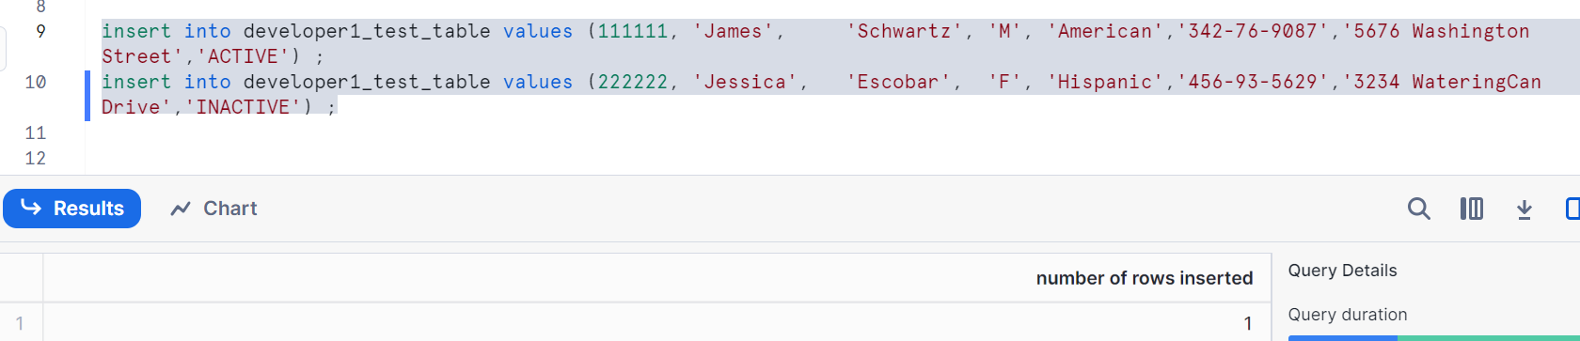
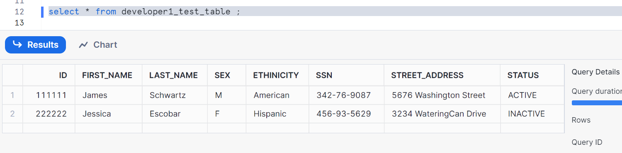

Existing table insert/update/delete
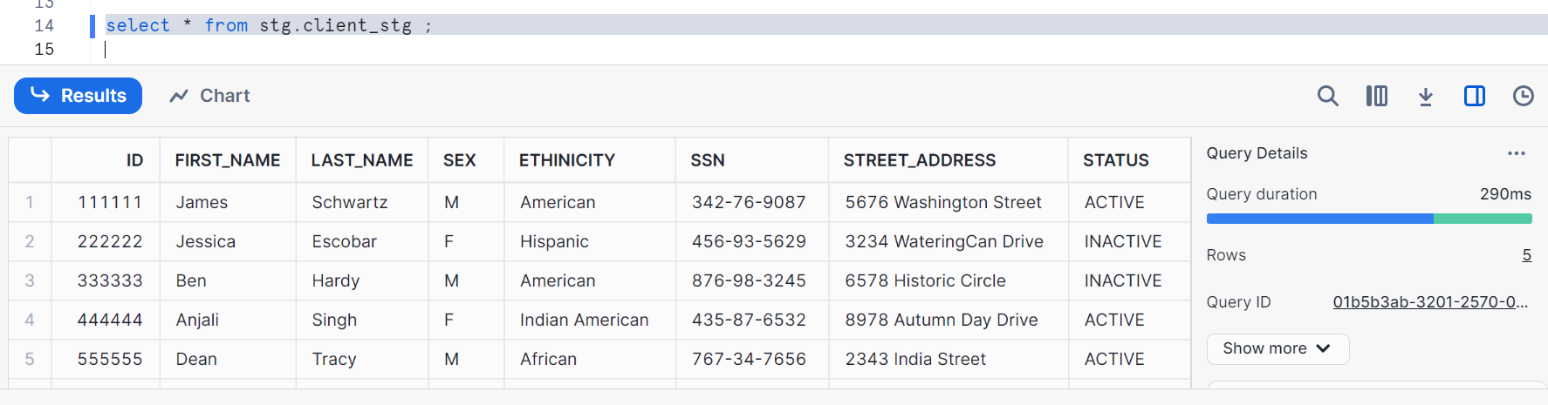
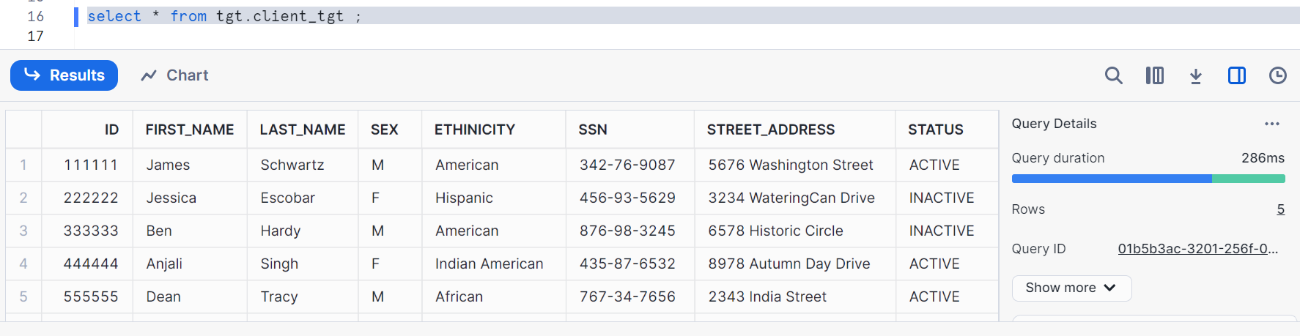
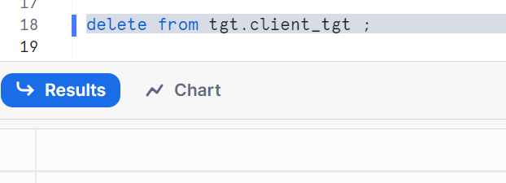
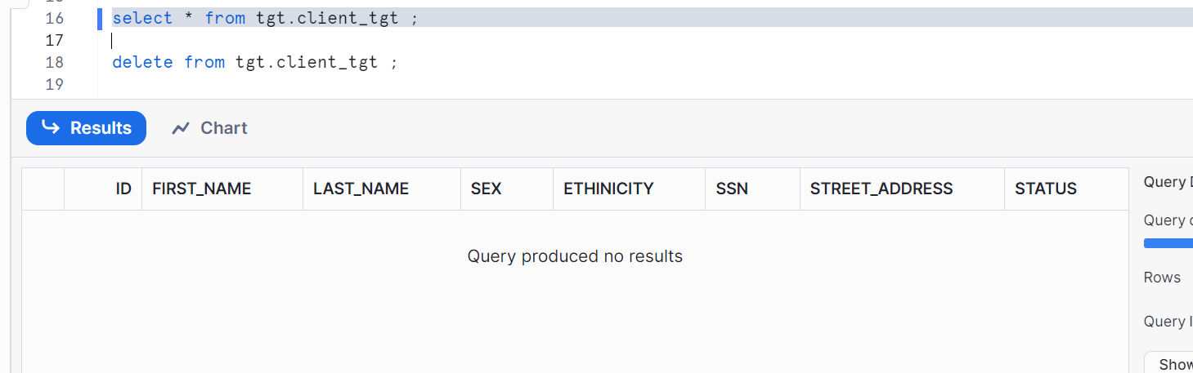
Executing the procedure
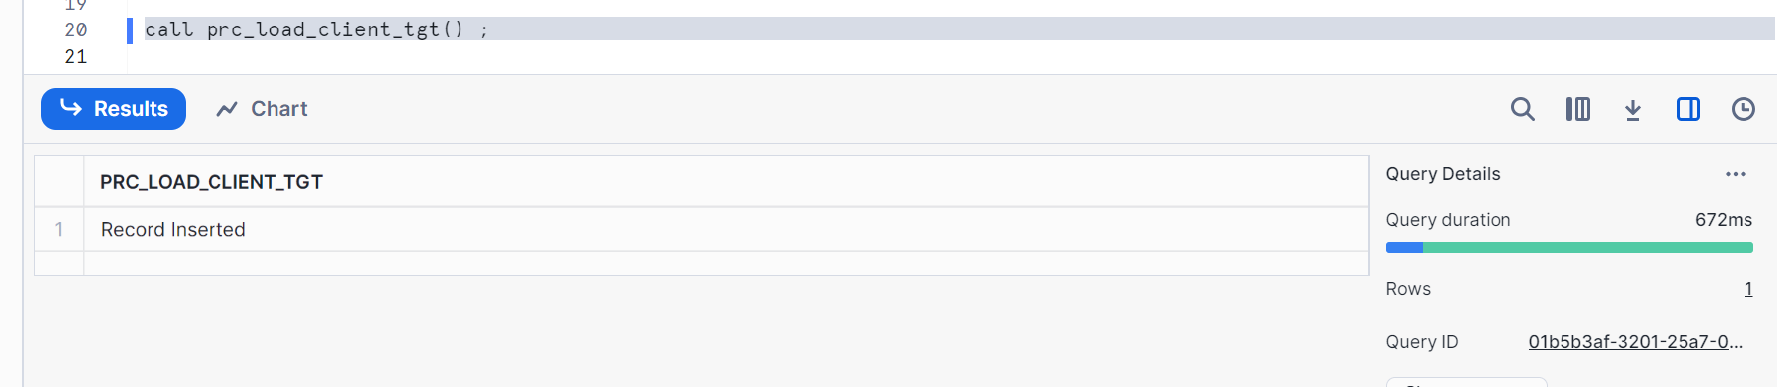
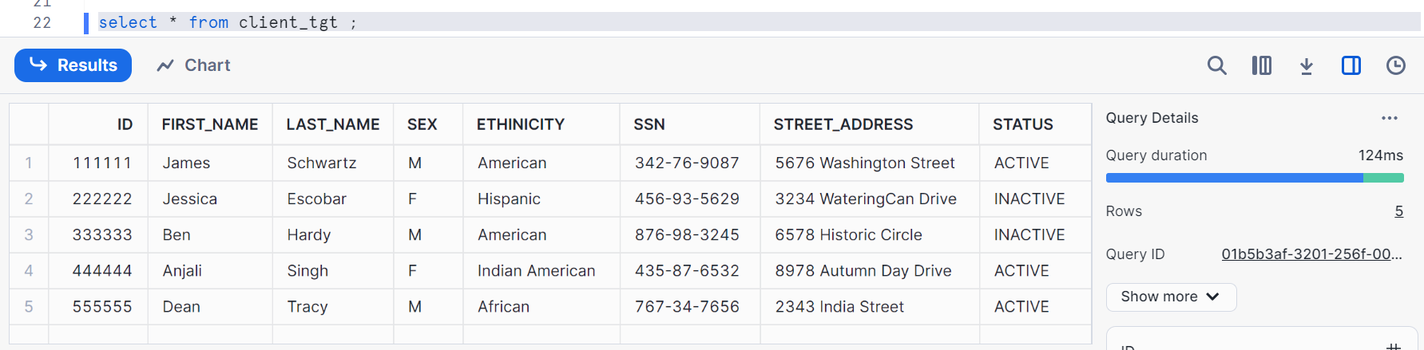
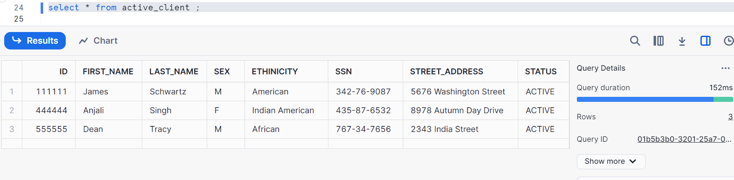
This is our developer role where we have validated create table, insert and delete, Hence everything is working properly
Login to developer2 & check the same as above
Everything for you should work properly

Let’s go to the QA role and check
Login to qa1 user
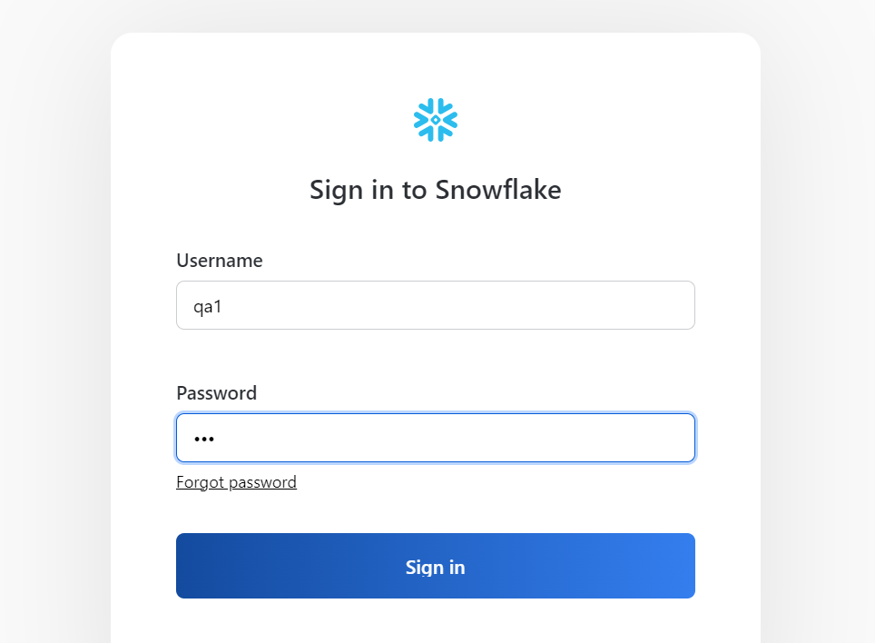
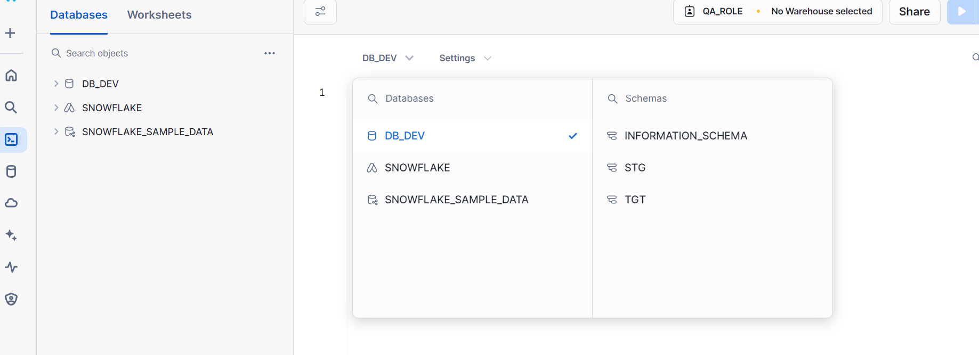
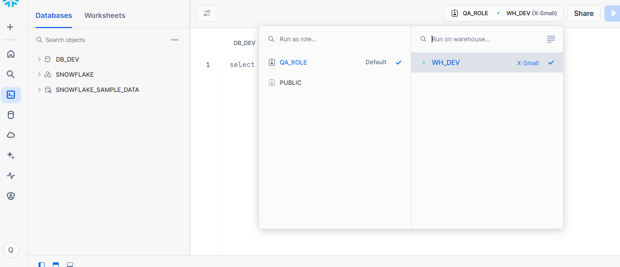
We have given a restriction to QA like they cannot insert the data into any table and rest can do everything as of developer
Let’s check
Try to create a table
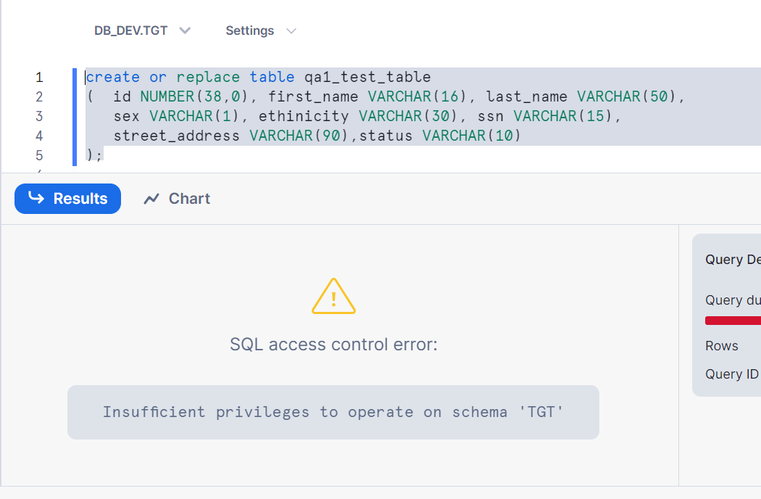
Table creation not allowed as you can see above
Now, existing table delete not allowed, check it
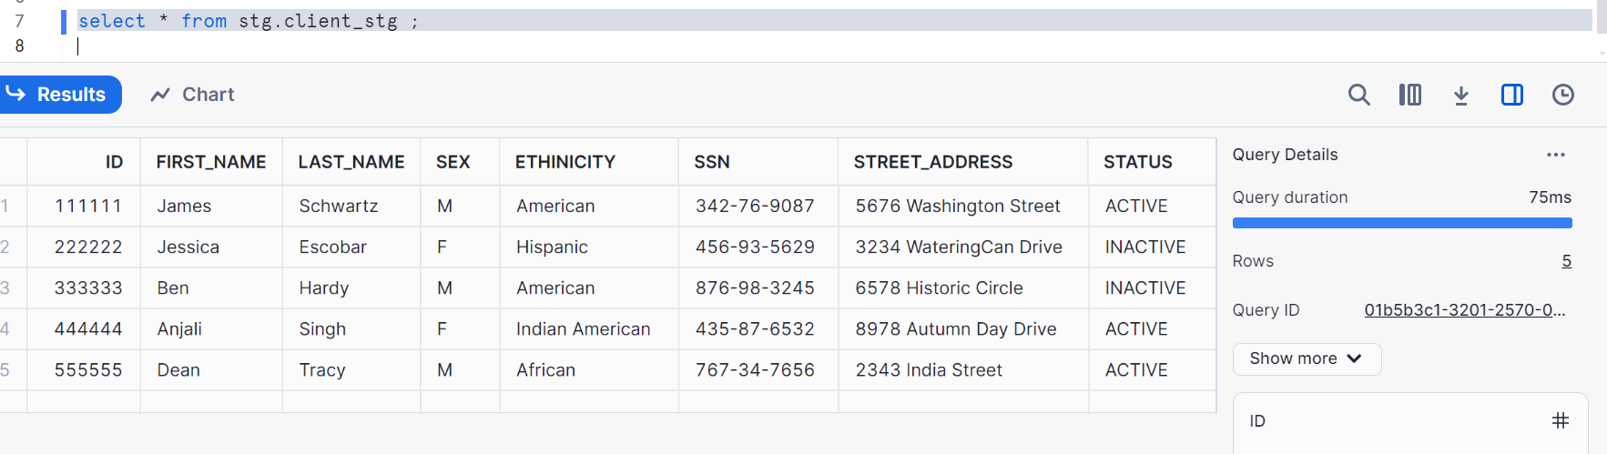
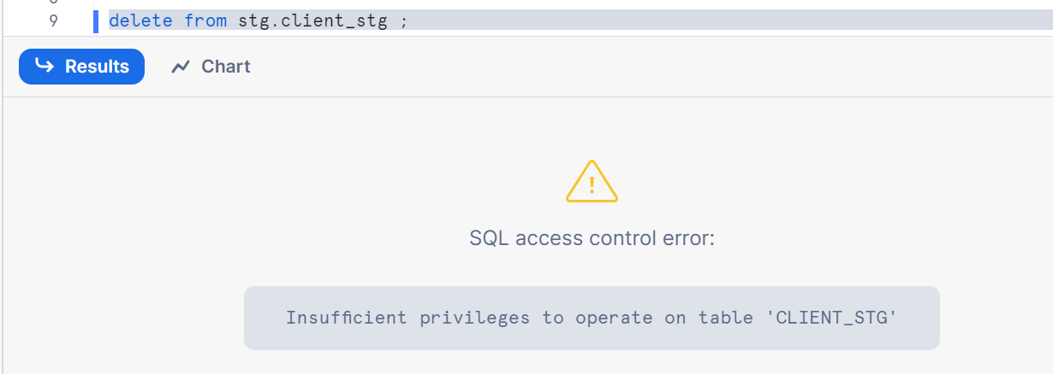
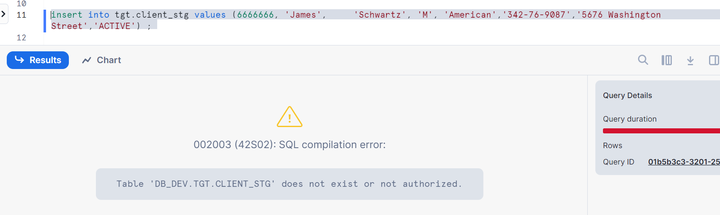
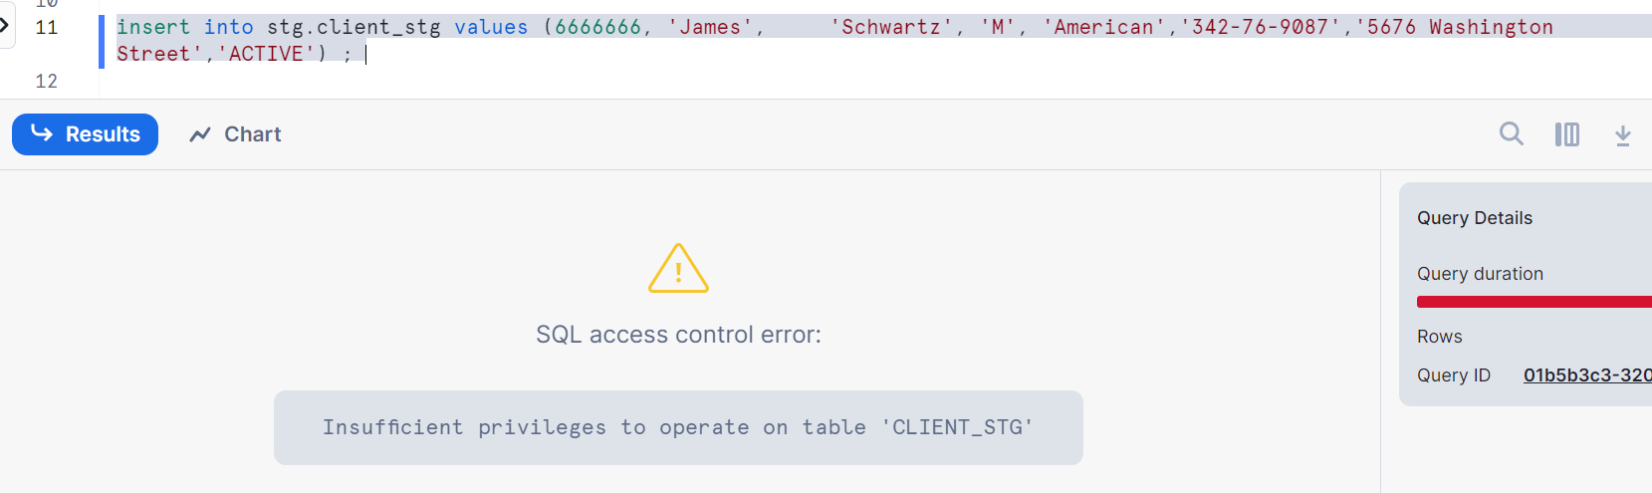
Let’s check on update
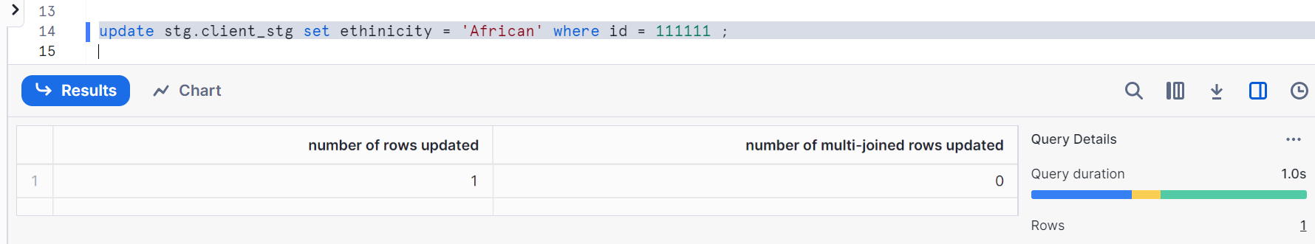
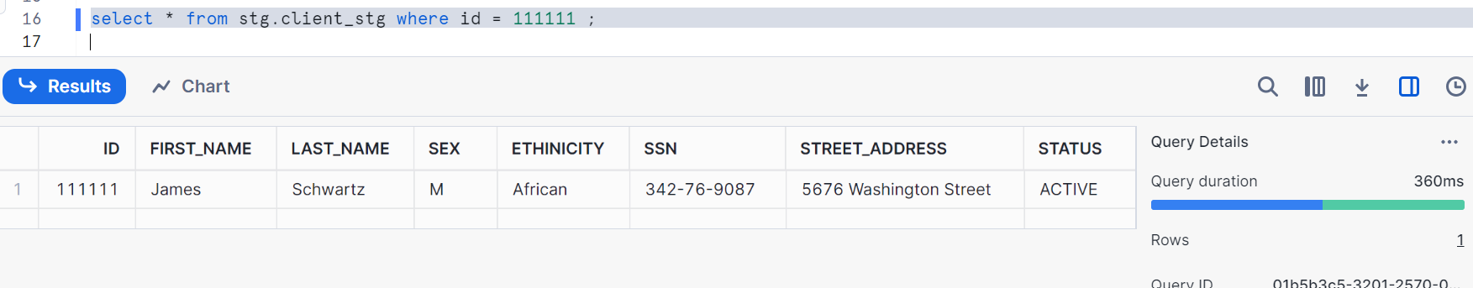
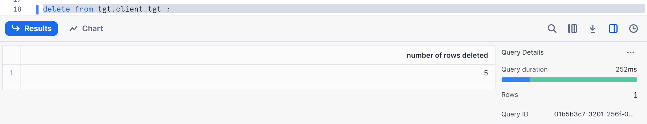
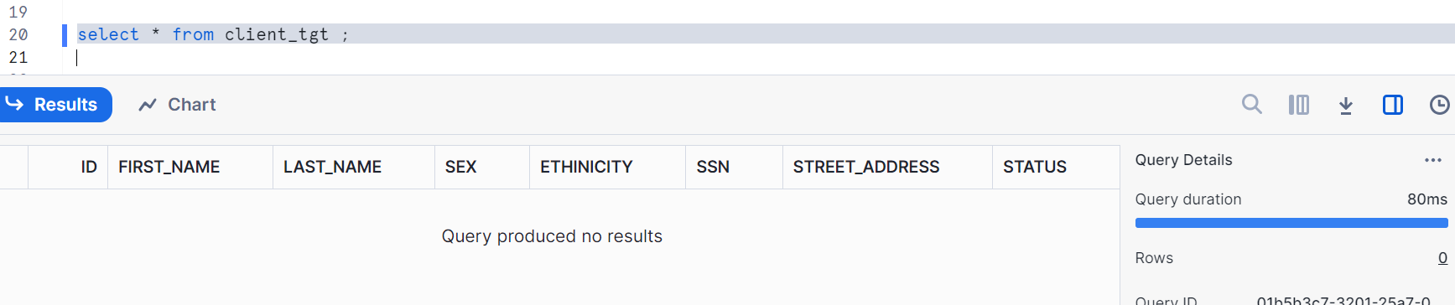

Let’s check with procedure
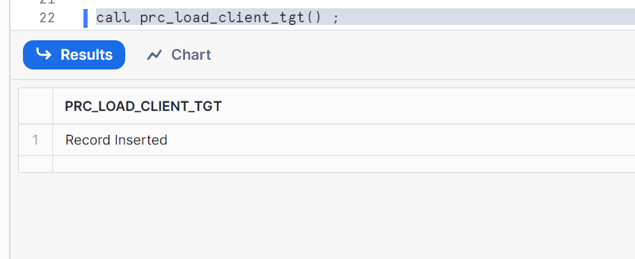
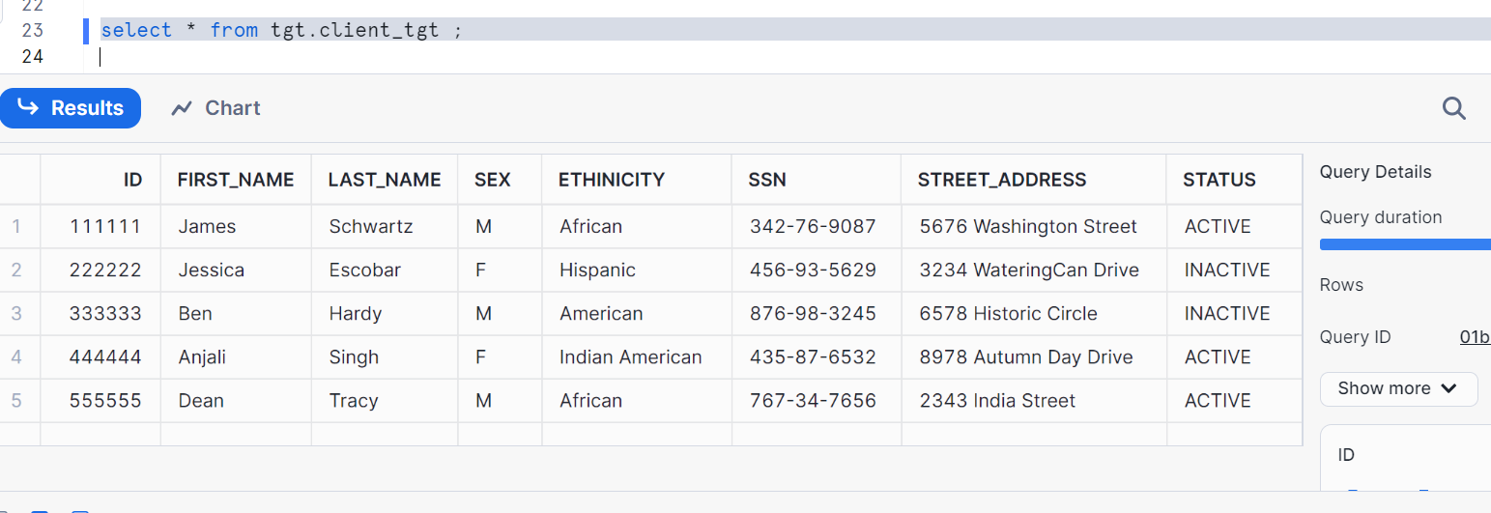
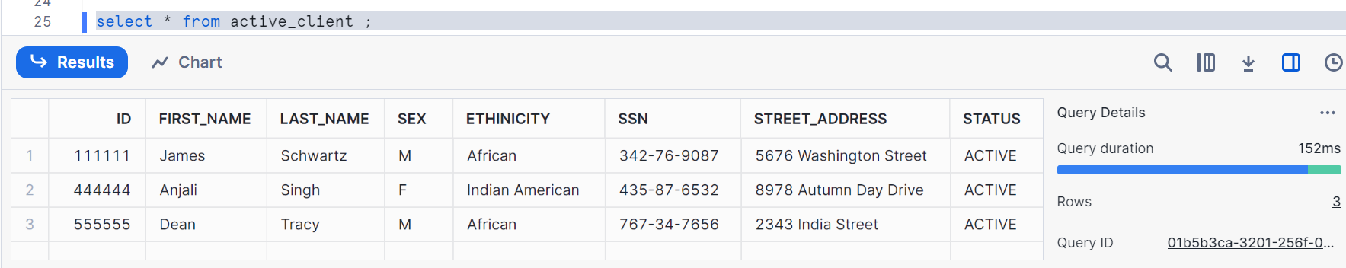

Hence we created a difference between developer and QA users as QA should not be able to insert the data or create the table or should not be deleting the staging table

Let’s check with reader_role
So, log into reader1 user
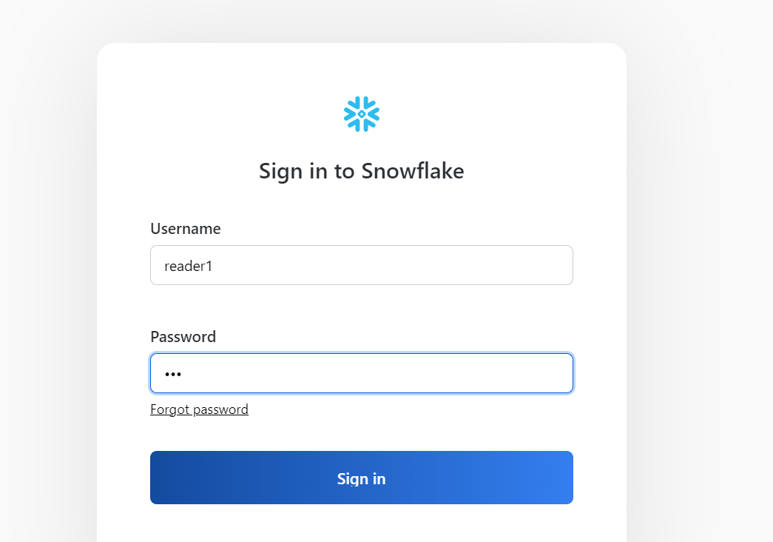
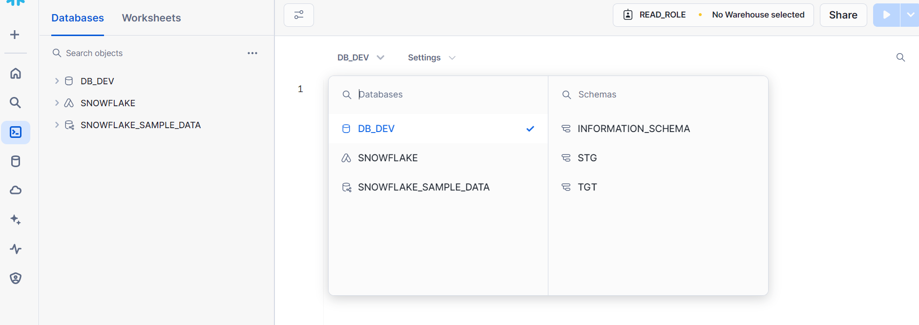
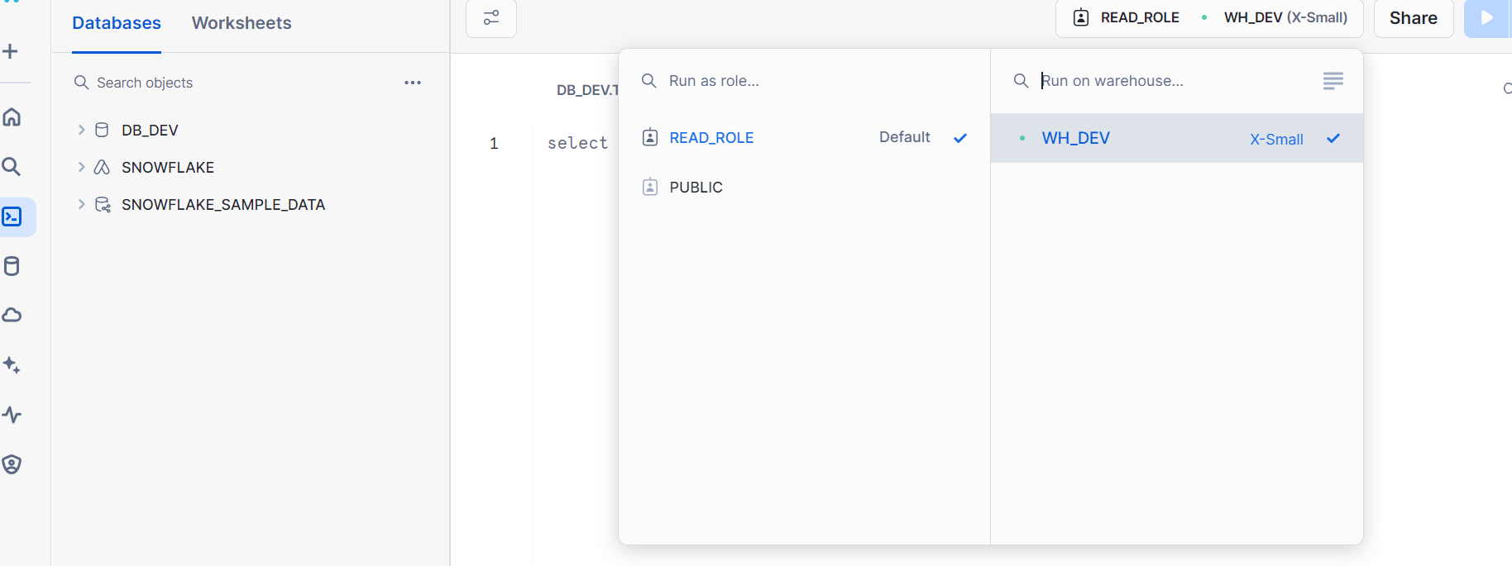
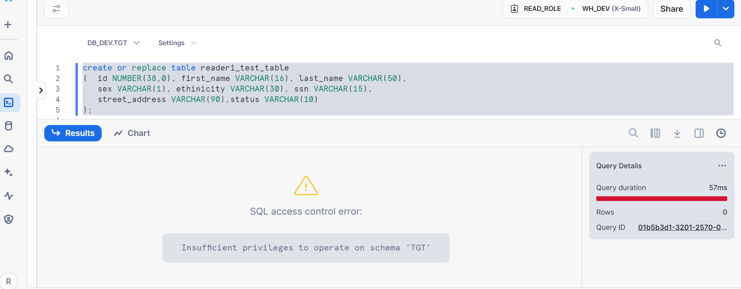
Table creation not allowed as expected
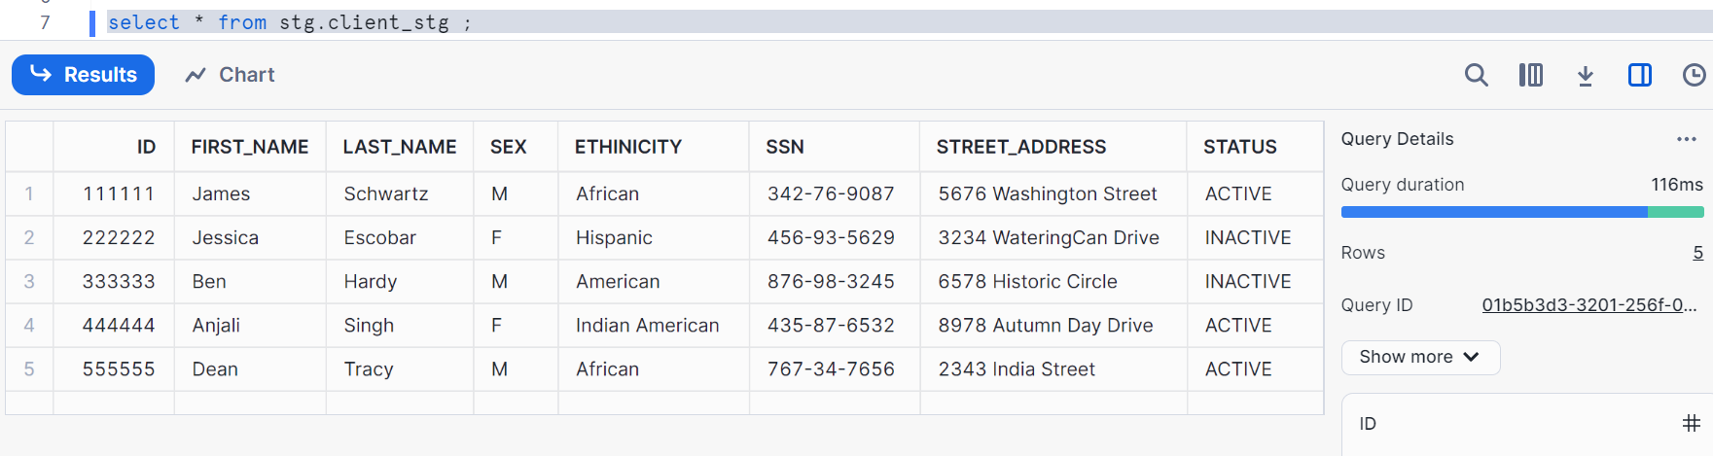
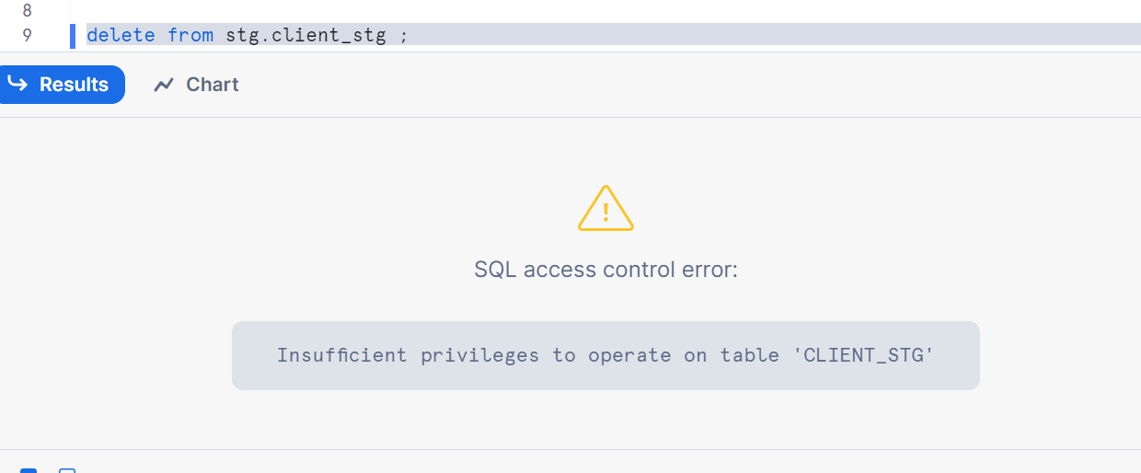
Delete not allowed
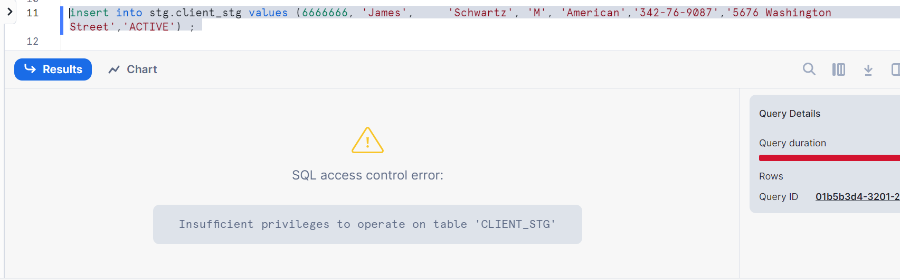
Insert not allowed
Check for update
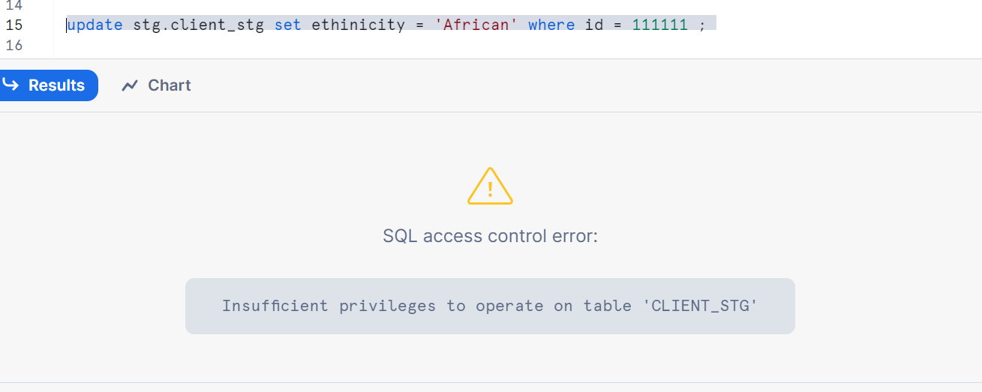
Execute the procedure
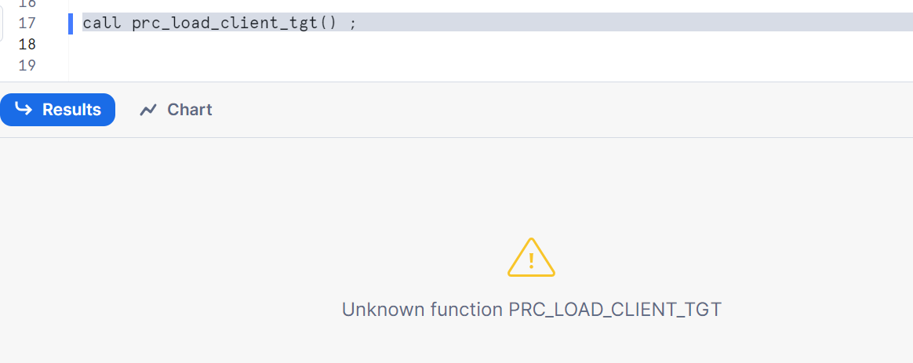
Procedure is not allowed
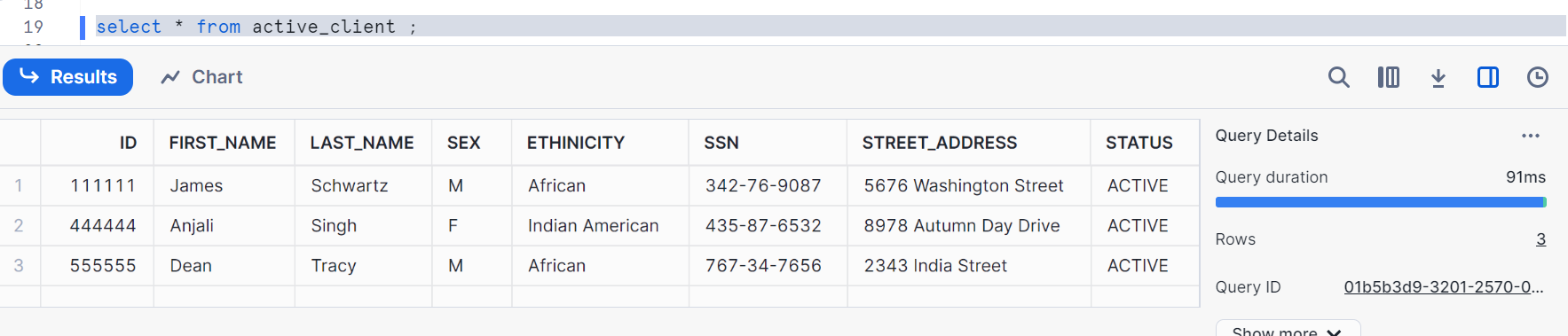
So, we can check the data in the view

Therefore, reader_role users can just read the data without changing any data

